Use

Fact

Recipe 1

Recipe 2

Hard

Recipe 1

Recipe 2

Medium

Recipe 1

Recipe 2

Easy

Recipes

Potato game

Potato Facts/uses outside of kitchen

HOME

Potatosel (Potato Carousel)

Navbar

Logo

Navbar

Logo

Picture + link

Picture + link

Picture + link

Hard

Picture + link

Picture + link

Picture + link

Picture + link

Picture + link

Picture + link

Picture + link

Picture + link

Picture + link

Medium

Easy

Logo

Navbar

Uses

Facts

Information

Navbar

Logo

Potato game

**Documentation:**

For my midterm project, I plan on make a website based around potatoes. I want to show that potatoes have a wide range of uses inside and outside of the kitchen. On the home page I plan on to make a massive carousel of rotating potato pictures. In the navbar I plan to have links to the recipes, facts and uses, and the game. The recipe page would have recipes ranging from easy to hard depending on the skills needed to make the dish. The facts and uses page should have a list of facts or uses and the ability to switch between the two for which will show up. The game page will hopefully have some sort of potato counting game in it.

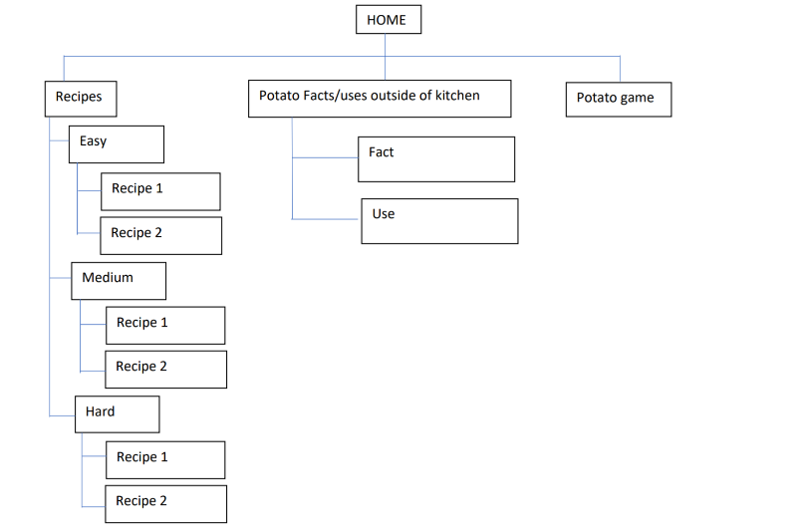Sitemap:

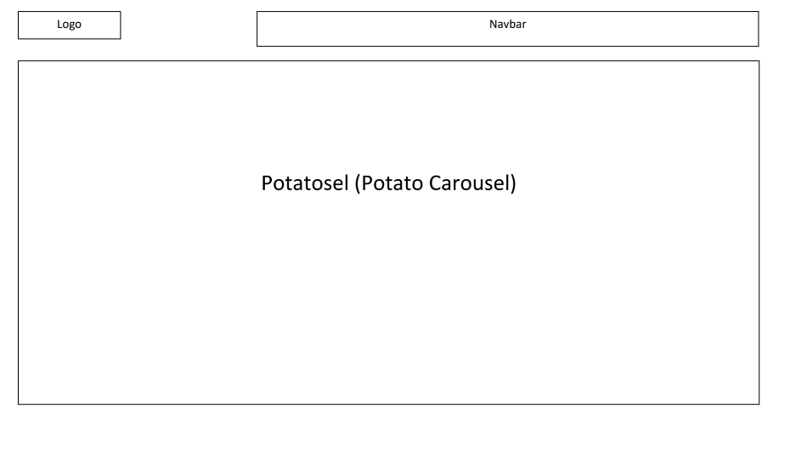Home:

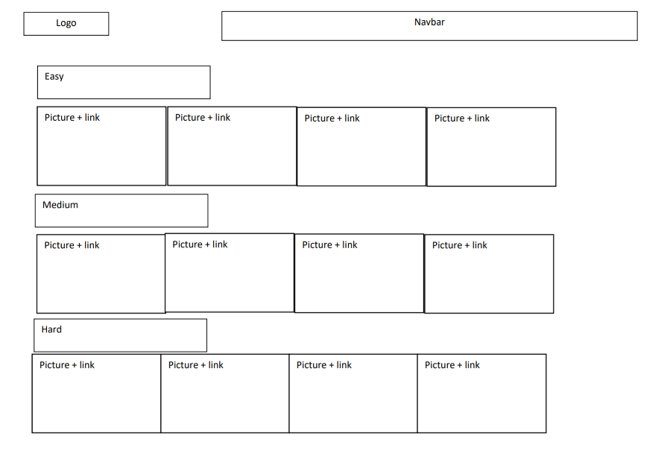Recipes:

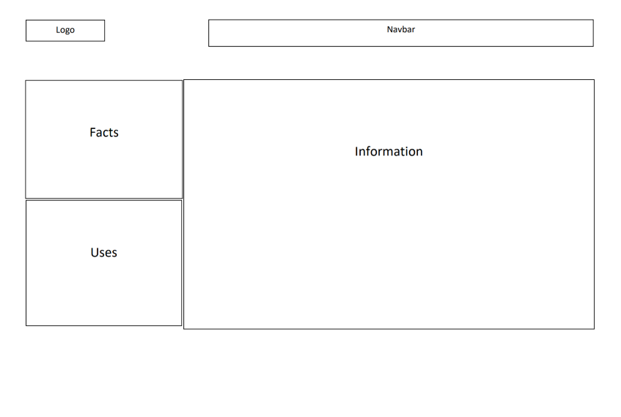Facts and Uses:

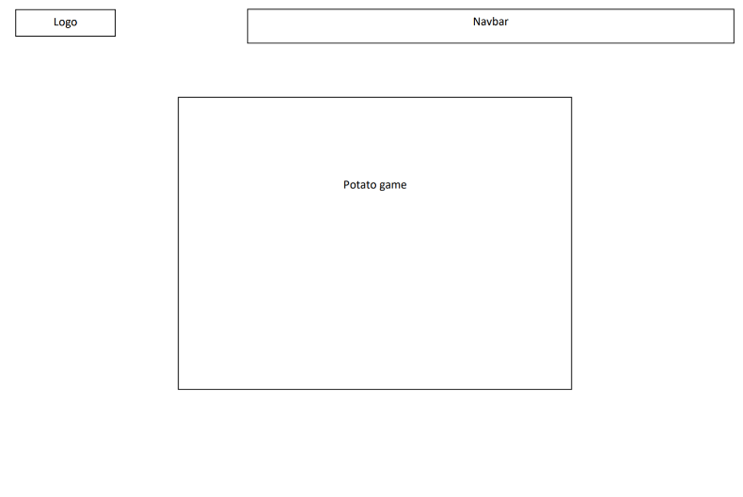Game:

**Inspiration:**

Layout idea: <https://www.engine.xyz/>

Game idea: The game Extreme Potato Counter on Neopets

**Skills Used and Skills to Learn:**

I think creating the recipes part of the website will require the use of a lot of divs to work with each other. I will also have to brush up on some javascript to see if I can make my game to work. For switching between my facts and uses, I’m not sure if I have learned of a way to switch text on the screen without changing pages and I also have to learn how to make a carousel.